**MODULE: 3.1 (C++ Basic)**

1. WAP to print “Hello World” using C++

Ans :

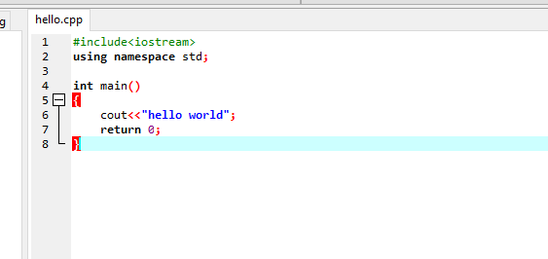

2. What is OOP? List OOP concepts

Ans:

Object-oriented programming aims to implement real-world entities like inheritance, hiding, polymorphism, etc. in programming. The main aim of OOP is to bind together the data and the functions that operate on them so that no other part of the code can access this data except that function.

List oops concept:

1. Class
2. Objects
3. Encapsulation
4. Abstraction
5. Polymorphism
6. Inheritance

3. What is the difference between OOP and POP?

Ans:

Following are the important differences between OOP and POP.

| **Sr. No.** | **Key** | **OOP** | **POP** |
| --- | --- | --- | --- |
| 1 | Definition | OOP stands for Object Oriented Programing. | POP stands for Procedural Oriented Programming. |
| 2 | Approach | OOP follows bottom up approach. | POP follows top down approach. |
| 3 | Division | A program is divided to objects and their interactions. | A program is divided into functions and they interacts. |
| 4 | Inheritance supported | Inheritance is supported. | Inheritance is not supported. |
| 5 | Access control | Access control is supported via access modifiers. | No access modifiers are supported. |
| 6 | Data Hiding | Encapsulation is used to hide data. | No data hiding present. Data is globally accessible. |
| 7 | Example | C++, Java | C, Pascal |